Captions and FPOs for Almeida and Worsley, *Romanticism and Antislavery Literatures*

**Ortiz, “Listening for Noise in Antislavery Poetry” (2 figs)**

Figure 1: “Admiral Hosier’s Ghost,” by Richard Glover (1740), colored etching by C. Mosley (1740), National Maritime Museum, Greenwich, London

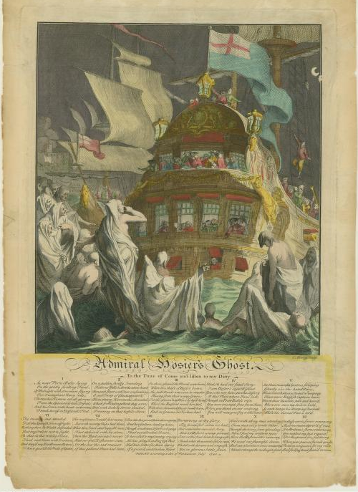

Figure 2: *Slave Ship* (*Slavers Throwing Overboard the Dead and Dying, Typhoon Coming On*), by J. M. W. Turner (1840), Museum of Fine Arts, Boston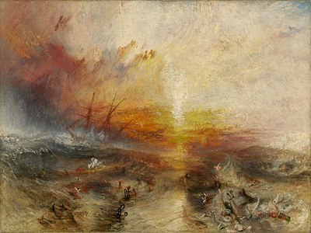

**Botkin “Tunyuhan: From the Field to the Classroom” (2 figs.)**

Figure 1: MaMa G., Author’s collection

****

Figure 2: Colonel Lumsden, *Quashie.* Oil on canvas, circa 2009. Lumsden family collection.

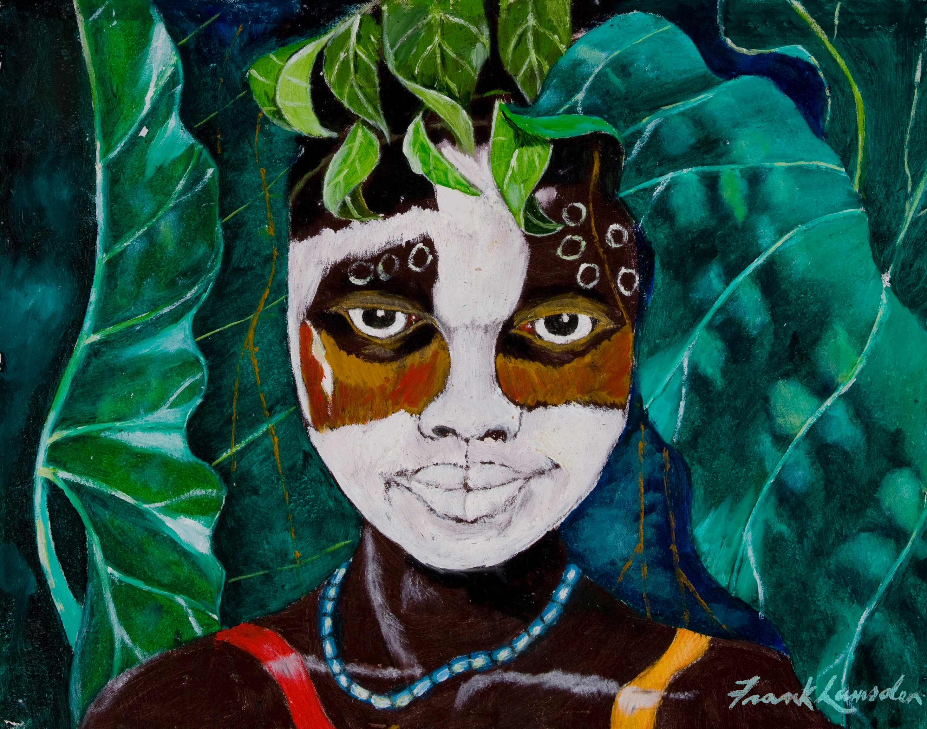

**Blaisdell, “Historical Agency and Civic Action through Antislavery Pedagogy” (3 figs)**

Figure 1: Black Lives Matter protest in July 2020 in Peabody, Massachusetts. Photo courtesy of Casey K. Perez.

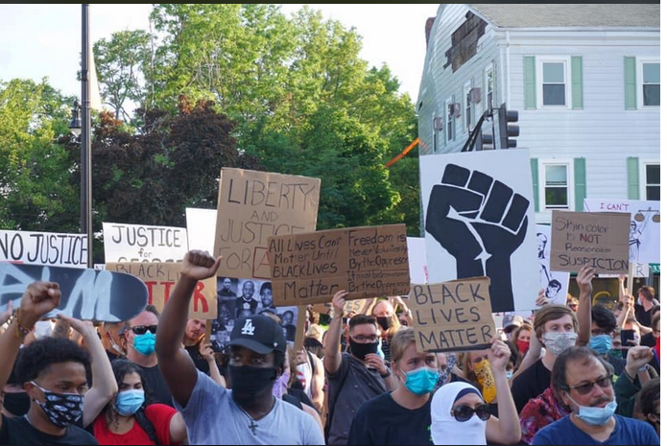

Figure 2: Black Lives Matter counterprotesters in West Peabody, Massachusetts. Photo by Jaime Campos of *The Salem News*,July 14, 2020, <https://photos.salemnews.com/The-Salem-News-Newspaper-/July-2020/i-Hmx6zLd>.

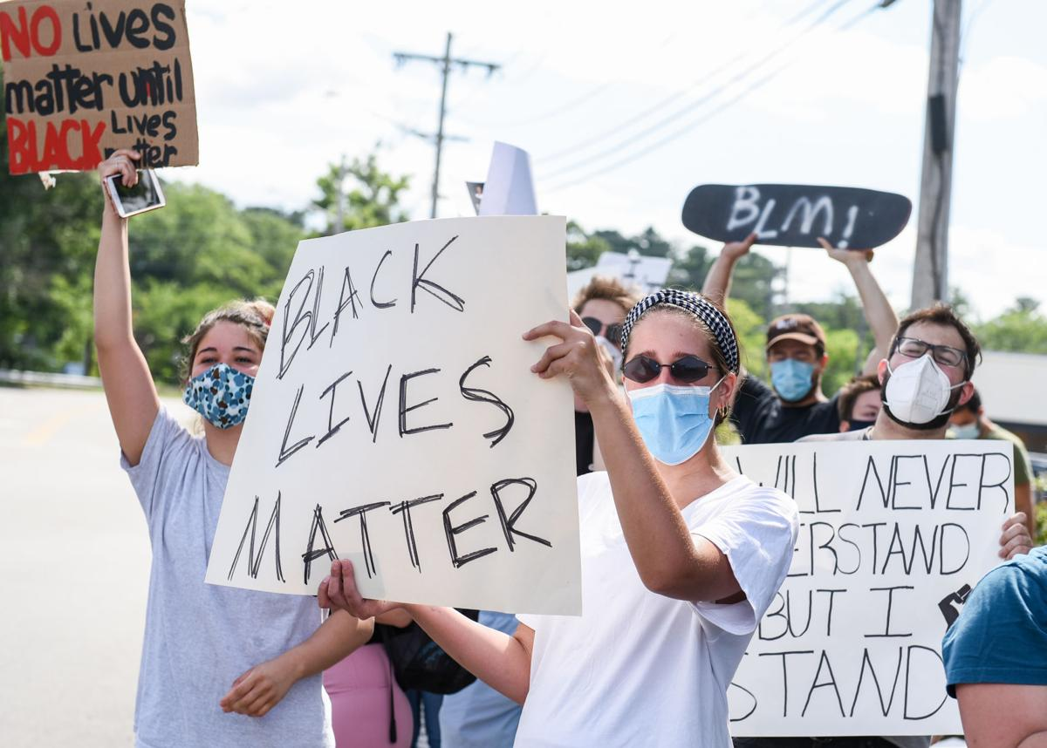

Figure 3: Peabody, Massachusetts police officer James Festa talking with protesters at Dianna Ploss’s rally. Photo by Jaime Campos of *The Salem News*, July 14, 2020, [https://photos.salemnews.com/The-Salem-News-Newspaper-/July-2020/i-v5GF5zR](https://photos.salemnews.com/The-Salem-News-Newspaper-/July-2020/i-v5GF5zR" \t "_blank).



Figure 4: The author’s presentation at the Undergraduate Research Conference, University of Massachusetts Amherst, April 2018.

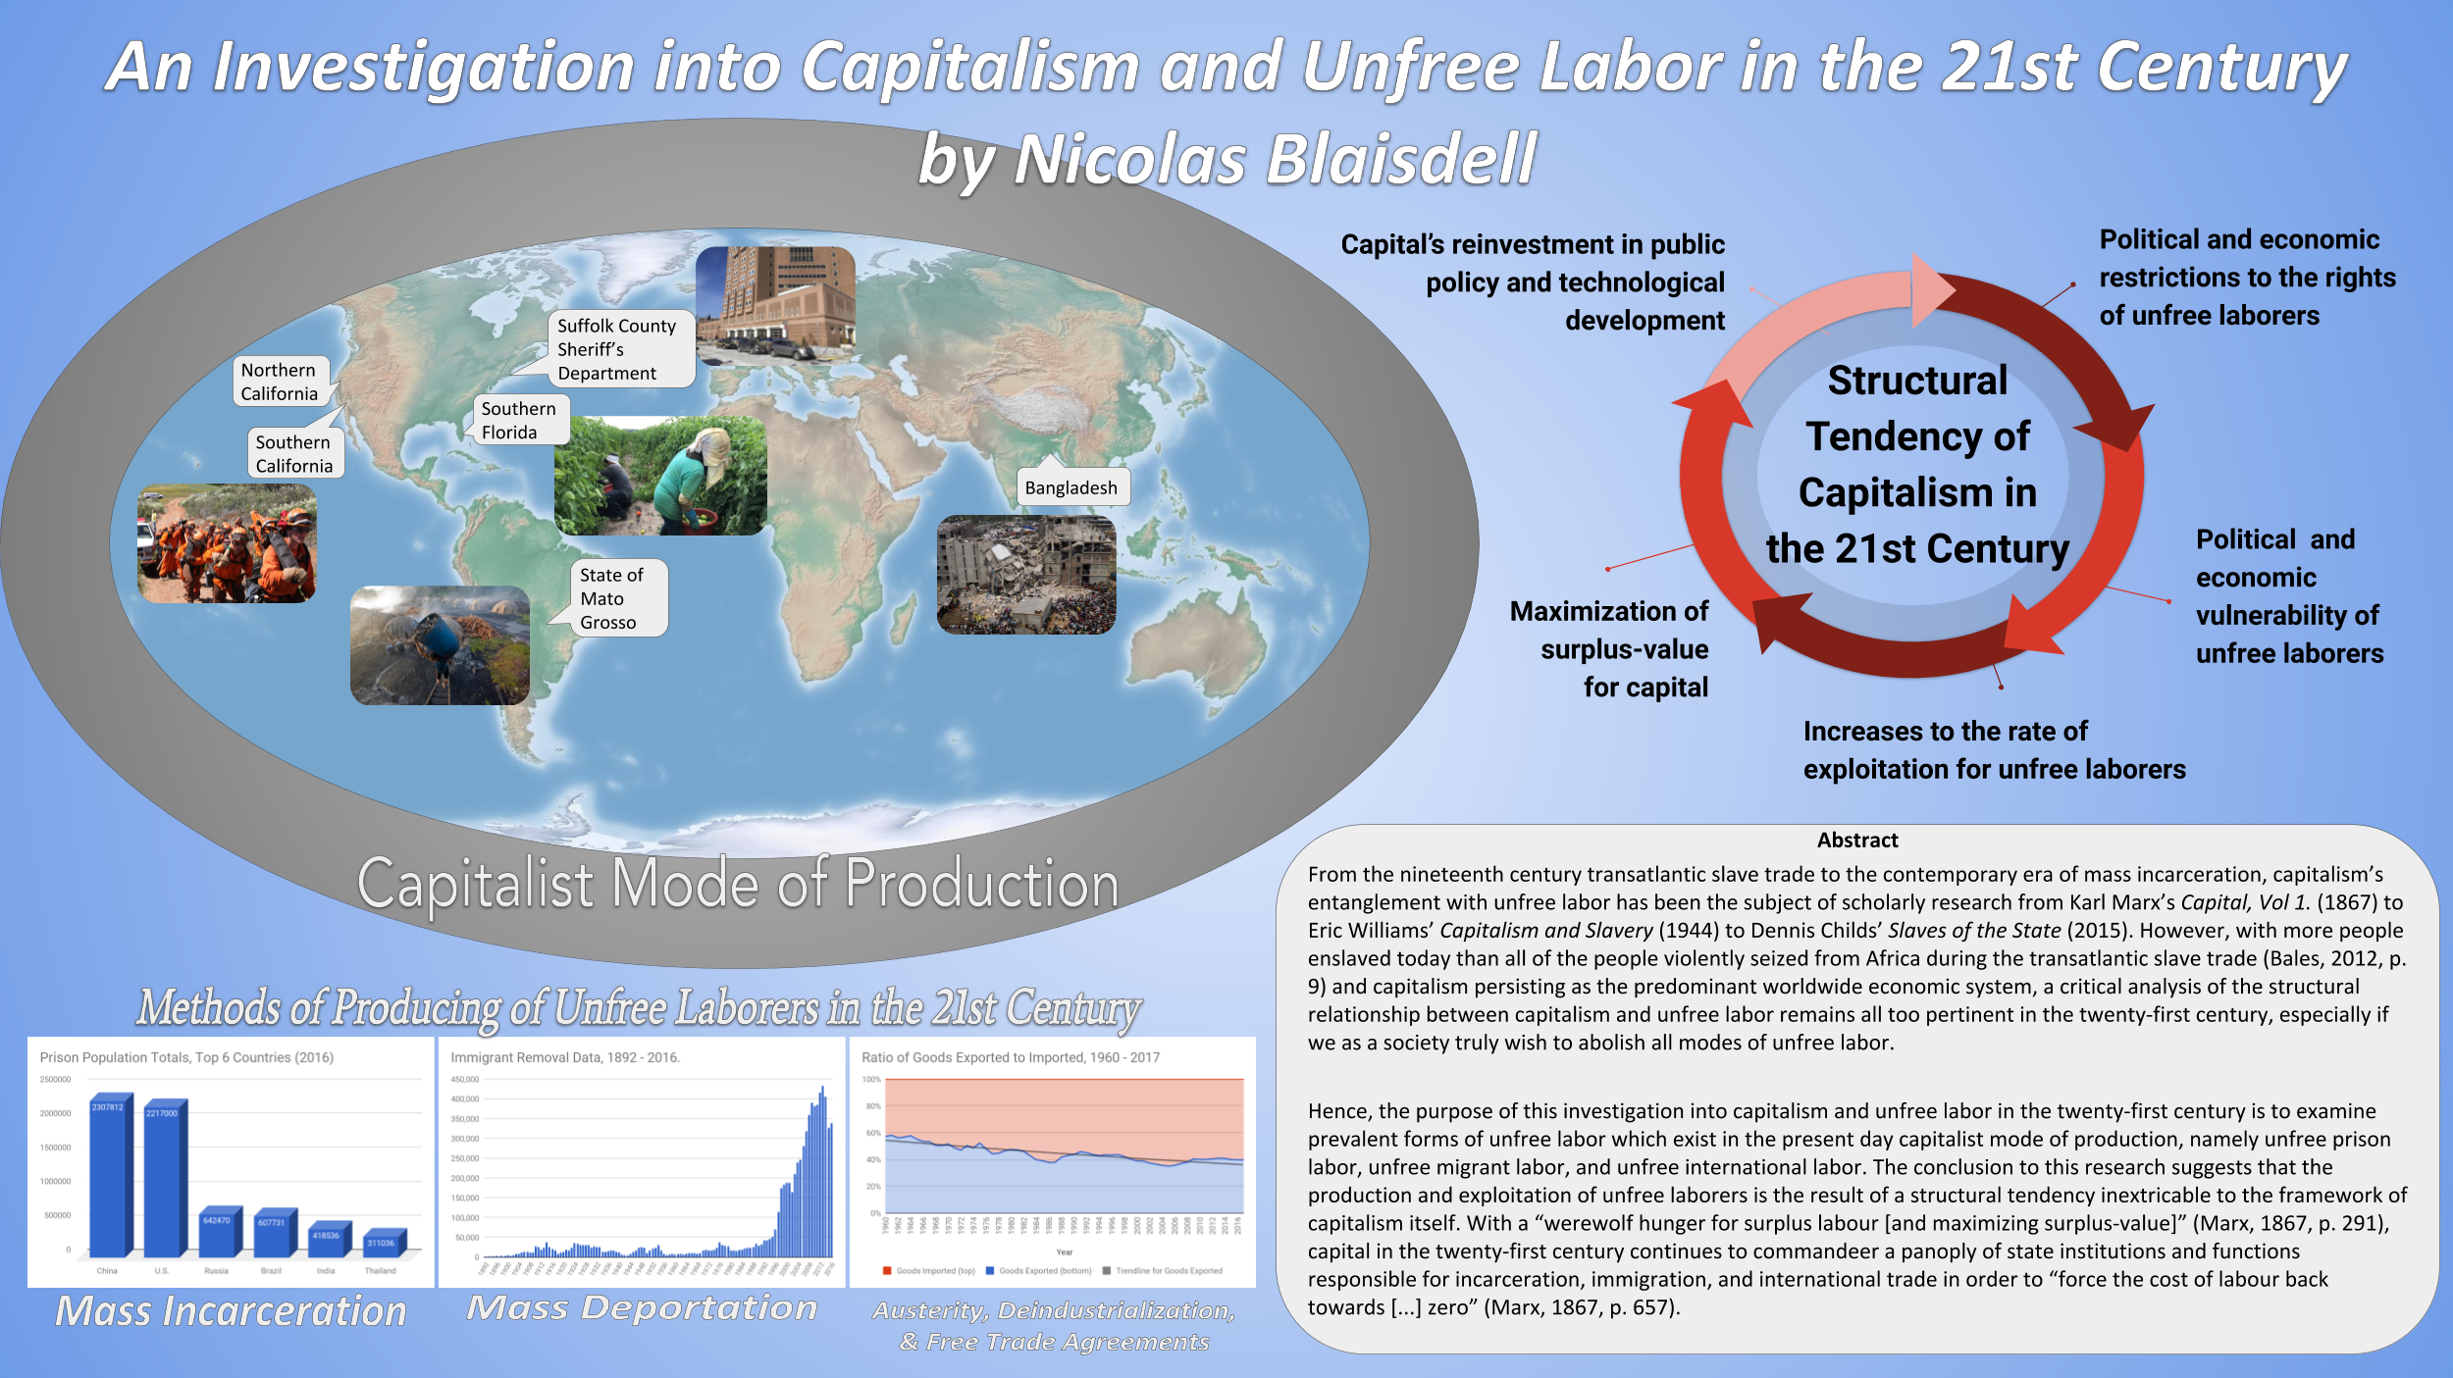

Figure 5: The school’s hoody cart

**